Zach Schultz

DS 745

Project 1

**Purpose of the Visualization**

The purpose of these visualizations is to show the stark differences in out of wedlock child birth rates between different racial groups in the United States. I recently heard a troubling statistic on this topic, and it prompted me to look deeper.

The variables in these charts are time, race, and % of out of wedlock births.

**Story**

We have a serious family problem in this country. 7/10 black kids, nearly the same for Native American kids, and 6/10 Hispanic kids are born out of wedlock. The trends for all American families are going in the wrong direction. There is ample evidence that children born to married parents have significant advantages to those who are not.

**Draft 1**

The first visualization is a ‘unit graph’ or pictogram. I intended to highlight the sheer numbers of babies being born out of wedlock in the country. Each circle represents one baby. The very high amount of circles for African American, American Indian, and Hispanic communities is meant to stick out. This graph was done using Microsoft Excel.

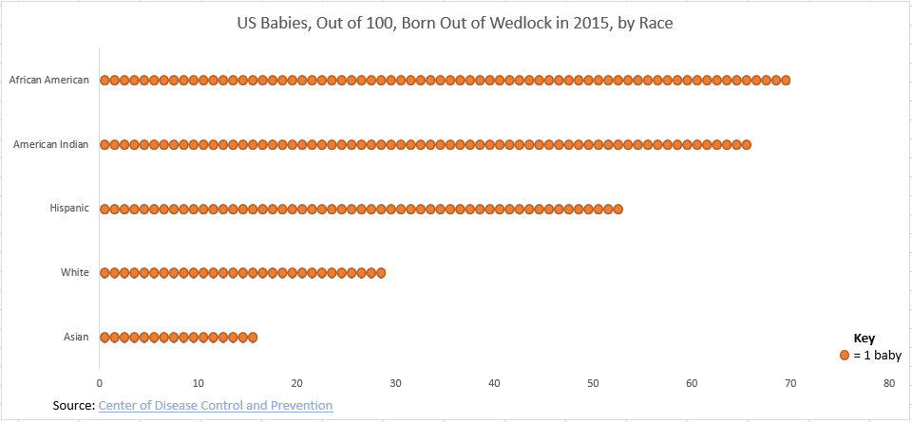

**Draft 2**

With more research, it became clear that another trend has been going on in recent decades. For all racial groups in America, the percentage of unmarried mothers having children has been steadily rising. Thus I wanted to add the dimension of time. Upon reflection, this graph left much to be desired in regards to color scheme, layout, and clarity.This graph was done using R and the plot() and line() functions.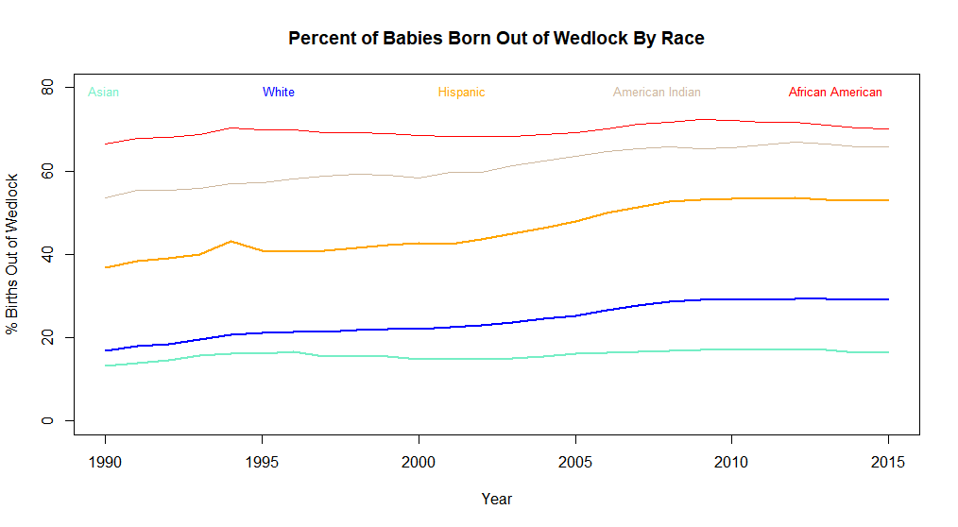

**Draft 3**

Draft 3 does a better job of highlighting the problems. The variables here are time and percent of births out of wedlock. We also can see a race variable. We can see the obvious trends going on as well as the large differences. This graph was inspired by this quote from *Beautiful Evidence.*

“I do not paint things, I paint only the differences between things.” Henri Matisse

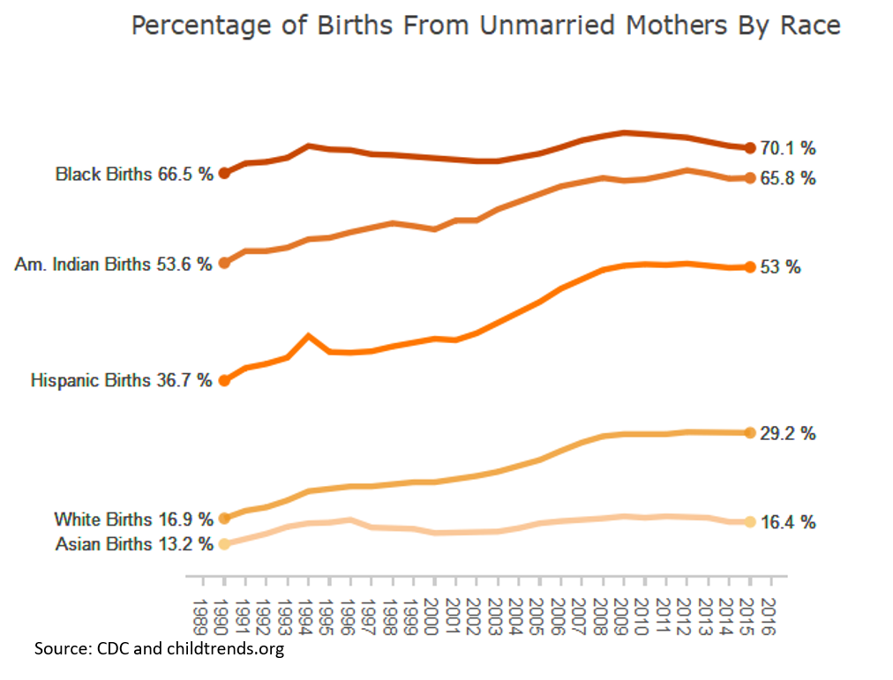

This visualization was done with R using plotly.

**Cleaning of Data**

There was some cleaning on the original CSV file. I removed some columns and rows in order to zoom in on 1990 - 2015. There was earlier data which shows the trends are even worse, but not each racial group was broken down. The original CSV file is here:



**Sources:**

* Data for 2007–2016: U.S. Department of Health and Human Services, Centers for Disease Control and Prevention, National Center for Health Statistics. (2018). CDC WONDER [Data tool]. Hyattsville, MD: Author. Retrieved from<http://wonder.cdc.gov/natality-current.html>.
* All other data for 1960–1999: Ventura, S. J. & Bachrach, C. A. (2000). Nonmarital childbearing in the United States, 1940–1999 [Table 4]. National Vital Statistics Reports, 48(16). Retrieved from<http://www.cdc.gov/nchs/data/nvsr/nvsr48/nvs48_16.pdf>**.**
* <https://www.childtrends.org/indicators/births-to-unmarried-women>
* Data for 2000–2006: U.S. Department of Health and Human Services, Centers for Disease Control and Prevention, National Center for Health Statistics. (2002–2009). Births: Final data for 2000–2006. Hyattsville, MD: Author. Retrieved from<http://www.cdc.gov/nchs/products/nvsr.htm>.